

02 July 2020

PHILIPPINE STOCK EXCHANGE, INC.
28th Street corner 5th Avenue,
PSE Tower, Bonifacio Global City,
Taguig City

Subject: Report on Number of Shareholders

For the Month Ended: June 30, 2020

Other Relevant Information:
In compliance with Section 17.6 of the Revised Disclosure Rules per Memo for Brokers No. 248-2003 Series of 2003 of the Philippine Stock Exchange, Inc. indicated above is our report on the number of shareholders owning at least one-board lot each as of June 30, 2020.

Filed on behalf by:
Name: Allan Ace Magdaluyo
Designation: Compliance Officer

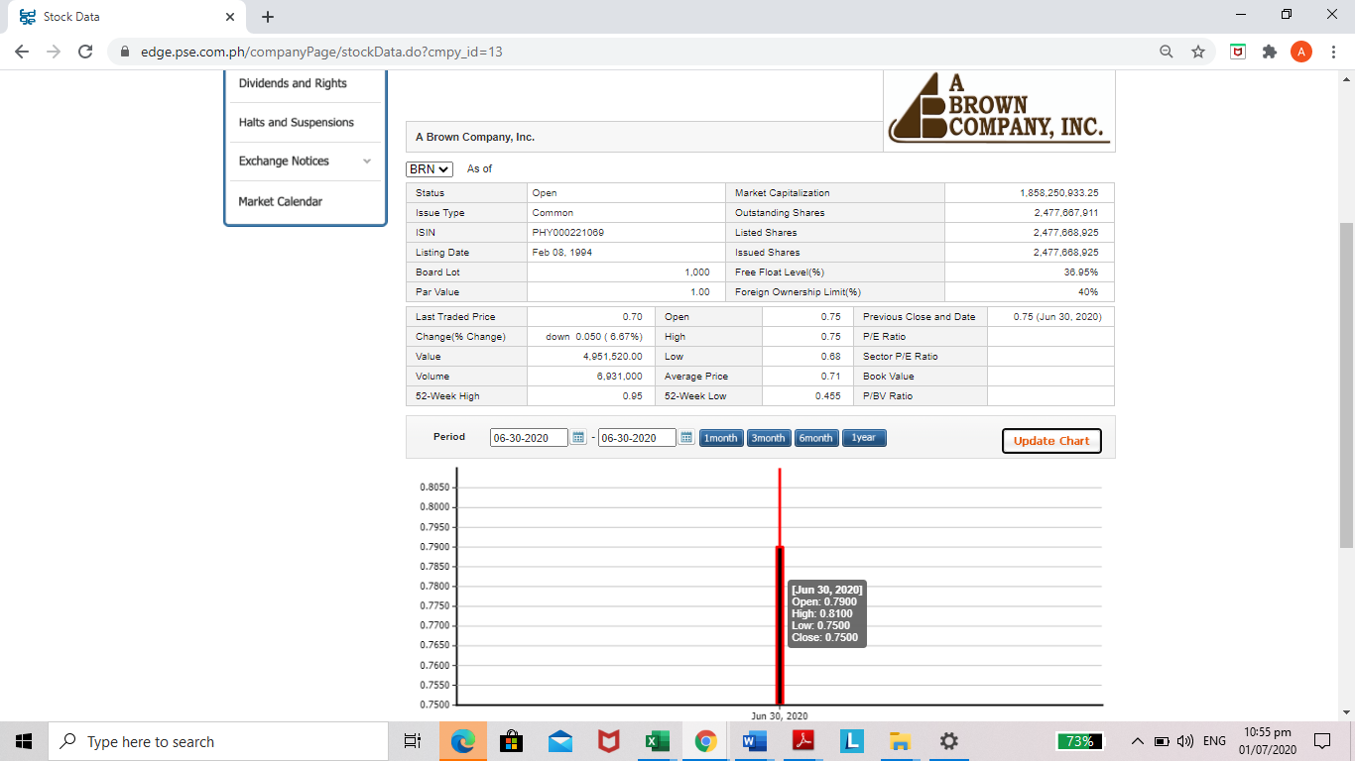

A Brown Company, Inc.
BRN
As of July 1, 2020 01:35 PM

Last Trade Price: | 0.70 |  | Open: | 0.75 |  | Previous Close:  Jun 30, 2020 | 0.75
Change: | down 0.05 |  | High: | 0.75 |  | P/E Ratio:  (Adjusted) | 5.83
%Change: | down 6.67% |  |  |  |  | P/E Ratio:  (Adjusted)
Value: | 4,951,520.00 |  | Low: | 0.68 |  | 52 week High: | 0.95
Volume: | 6,931,000 |  | Avg. Price: | 0.71 |  | 52 week Low: | 0.455

- Security Information
- Profile
- Chart
- Historical Data

Price for the Last 30 Days
30-day High:
0.81
30-day Low:
0.51
Date | Open | High | Low | Close | Average | Volume | Value
Jul 01, 2020 | 0.75 | 0.75 | 0.68 | 0.70 | 0.71 | 6,931,000 | 4,951,520.00

Jun 30, 2020 | 0.79 | 0.81 | 0.75 | 0.75 | 0.78 | 11,338,000 | 8,835,450.00
Jun 29, 2020 | 0.73 | 0.79 | 0.72 | 0.77 | 0.76 | 9,648,000 | 7,350,680.00

Jun 26, 2020 | 0.72 | 0.75 | 0.72 | 0.74 | 0.74 | 6,708,000 | 4,937,360.00
Jun 25, 2020 | 0.70 | 0.72 | 0.68 | 0.71 | 0.70 | 3,850,000 | 2,702,270.00

Jun 24, 2020 | 0.69 | 0.74 | 0.69 | 0.72 | 0.72 | 6,415,000 | 4,626,990.00
Jun 23, 2020 | 0.72 | 0.75 | 0.66 | 0.69 | 0.70 | 10,537,000 | 7,364,150.00

Jun 22, 2020 | 0.63 | 0.72 | 0.63 | 0.70 | 0.68 | 7,299,000 | 4,947,530.00
Jun 19, 2020 | 0.64 | 0.69 | 0.62 | 0.63 | 0.66 | 9,051,000 | 5,964,540.00

Jun 18, 2020 | 0.59 | 0.65 | 0.56 | 0.63 | 0.60 | 6,571,000 | 3,943,500.00
Jun 17, 2020 | 0.59 | 0.59 | 0.56 | 0.59 | 0.57 | 1,410,000 | 797,140.00

Jun 16, 2020 | 0.57 | 0.59 | 0.56 | 0.58 | 0.57 | 865,000 | 491,260.00
Jun 15, 2020 | 0.61 | 0.61 | 0.57 | 0.57 | 0.58 | 1,371,000 | 794,520.00

Jun 11, 2020 | 0.61 | 0.61 | 0.59 | 0.60 | 0.60 | 660,000 | 394,970.00
Jun 10, 2020 | 0.63 | 0.64 | 0.59 | 0.60 | 0.61 | 2,862,000 | 1,758,980.00

Jun 09, 2020 | 0.62 | 0.63 | 0.62 | 0.63 | 0.62 | 4,093,000 | 2,553,310.00
Jun 08, 2020 | 0.58 | 0.62 | 0.58 | 0.60 | 0.60 | 4,210,000 | 2,537,600.00

Jun 05, 2020 | 0.58 | 0.58 | 0.57 | 0.58 | 0.57 | 937,000 | 538,650.00
Jun 04, 2020 | 0.59 | 0.60 | 0.56 | 0.57 | 0.57 | 1,954,000 | 1,114,720.00

Jun 03, 2020 | 0.58 | 0.60 | 0.57 | 0.58 | 0.58 | 2,436,000 | 1,424,270.00
Jun 02, 2020 | 0.55 | 0.59 | 0.55 | 0.57 | 0.57 | 1,639,000 | 930,400.00

Jun 01, 2020 | 0.54 | 0.55 | 0.54 | 0.54 | 0.54 | 603,000 | 326,170.00
May 29, 2020 | 0.54 | 0.56 | 0.54 | 0.54 | 0.55 | 988,000 | 539,570.00

May 28, 2020 | 0.52 | 0.54 | 0.52 | 0.54 | 0.53 | 11,000 | 5,820.00
May 27, 2020 | 0.54 | 0.55 | 0.52 | 0.53 | 0.53 | 402,000 | 214,310.00

May 26, 2020 | 0.54 | 0.54 | 0.52 | 0.54 | 0.53 | 206,000 | 109,030.00
May 22, 2020 | 0.52 | 0.54 | 0.52 | 0.54 | 0.53 | 349,000 | 183,690.00

May 21, 2020 | 0.52 | 0.54 | 0.51 | 0.53 | 0.52 | 281,000 | 147,050.00
May 20, 2020 | 0.53 | 0.54 | 0.52 | 0.54 | 0.52 | 910,000 | 477,500.00

May 19, 2020 | 0.53 | 0.54 | 0.52 | 0.53 | 0.53 | 551,000 | 292,030.00
Download

